Designing a DAB using Scaling Laws

Reference: https://ridleyengineering.com/images/webinar/DAB_Design_Using_Scaling_Laws.pdf

Aims:
LV stage:
Vnom = 42 V
Vmin = 23.8 V
Vmax = 58.8 V
Pnominal = 800 W
Imax = 35.3 A

HV stage:
Vnom = 400 V
Vmax = 420 V
Vmin = 360 V
Pnominal = 800 W
Imax = 2.22 A

Fsw starting point = 1000 kHz
Choose a Single Phase Shift mode
I.e. (Intra bridge) Angle 1 = 180 °
(Inter bridge) Angle 2 = Control angle up to 45 °
Gain = 1

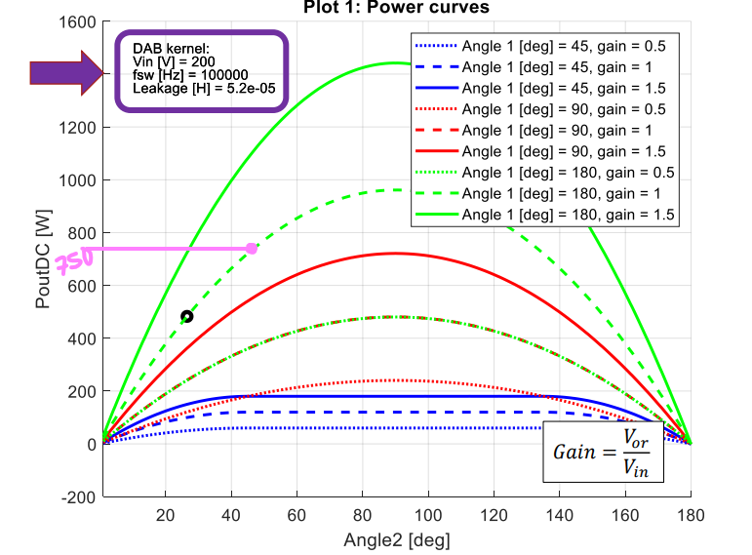

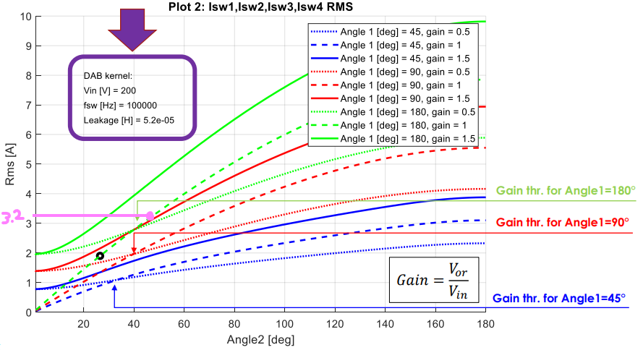
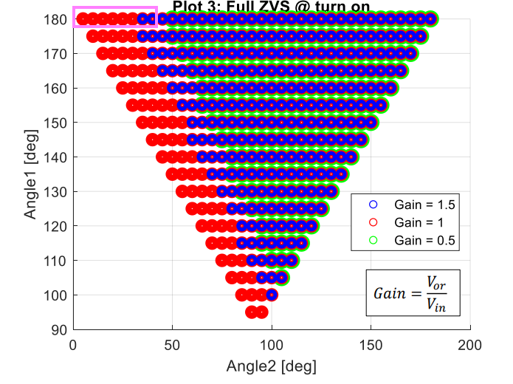

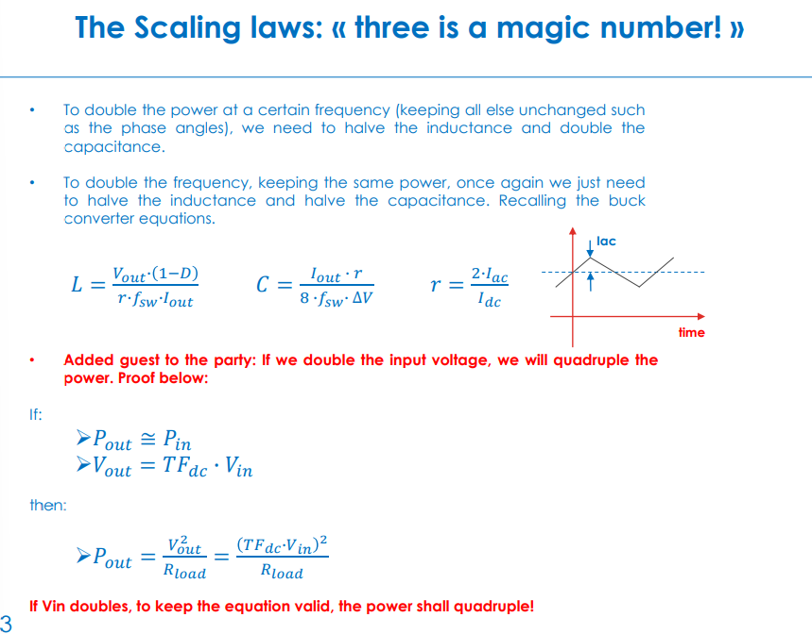

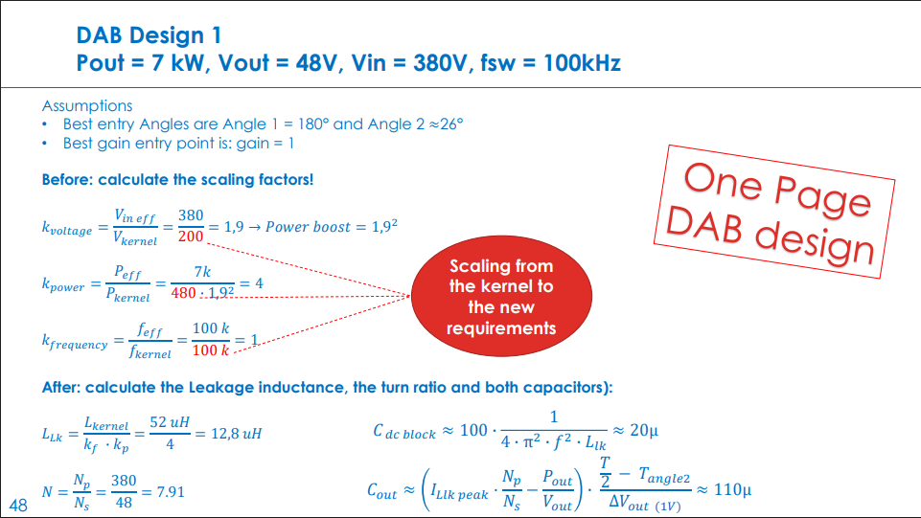

Kernel power: 1050 W (Angle 1 = 180 °, Angle 2 = 45 °, Gain = 1.5)
Kernel Fsw = 100 kHz
Kernel Leakage = 5.2e-05 H
Kernel Input voltage: 200 V
I_Llk_peak = 10 A

Aims:
LV stage:
Vnom = 42 V
Vmin = 23.8 V
Vmax = 58.8 V
Pnominal = 800 W
Imax = 35.3 A

To cope with the high voltage input range, we need to make use of the non linear DAB characteristics.
We want to operate the DAB at 1.5 gain, Angle2 at 60 degrees, at the lowest part of the voltage range.
This results in a L_lk of ~115 nH and a C_dcblock of ~22 uF.
How practical is a L_lk of 115 nH?

HV stage:
Vnom = 400 V
Vmax = 420 V
Vmin = 360 V
Pnominal = 800 W
Imax = 2.22 A

Fsw starting point = 1000 kHz
T = 1 / 1000 kHz = 1 us
Tangle2 = 0.125*T = 0.125 us
Choose a Single Phase Shift mode
I.e. (Intra bridge) Angle 1 = 180 °
(Inter bridge) Angle 2 = Control angle up to 45 °
Gain = 1

k_voltage = Vin_eff / Vkernel = 42 / 200 = 0.21 -> Power “boost” 0.24^2 = 0.00441
k_power = Peff / Pkernel = 800 / (750*0.21^2) = 24.187
k_frequency = f_eff / f_kernel = 1000 k / 100 k = 10

L_lk = Lkernel / (k_frequency x k_power) = 52 uH / (10*24.187) = 0.215 uH
C_dcblock = 100 x ( 1 / (4 x pi^2 x f^2 x L_lk) = 12 uF
N = Np / Ns = 42 / 400 = 0.105

CHECK FROM HERE
I_Llk_peak = (I_Llk_peak_kernel * k_voltage) * (Peff / Pkernel) = (10 * 0.24) / (5000 / 750) = 277.77 A
Cout = (I_Llk_peak * (N - Pout / Vout)) * ( (T/2 - Tangle2) / deltaVout) = (277.77 * 0.114 - 5000/420) * ( (10u/2 - 1.25u) / 1) = 105 uF

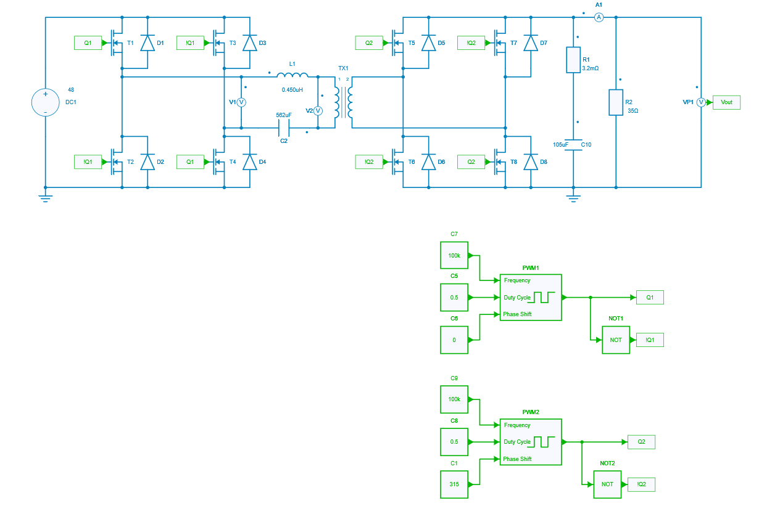
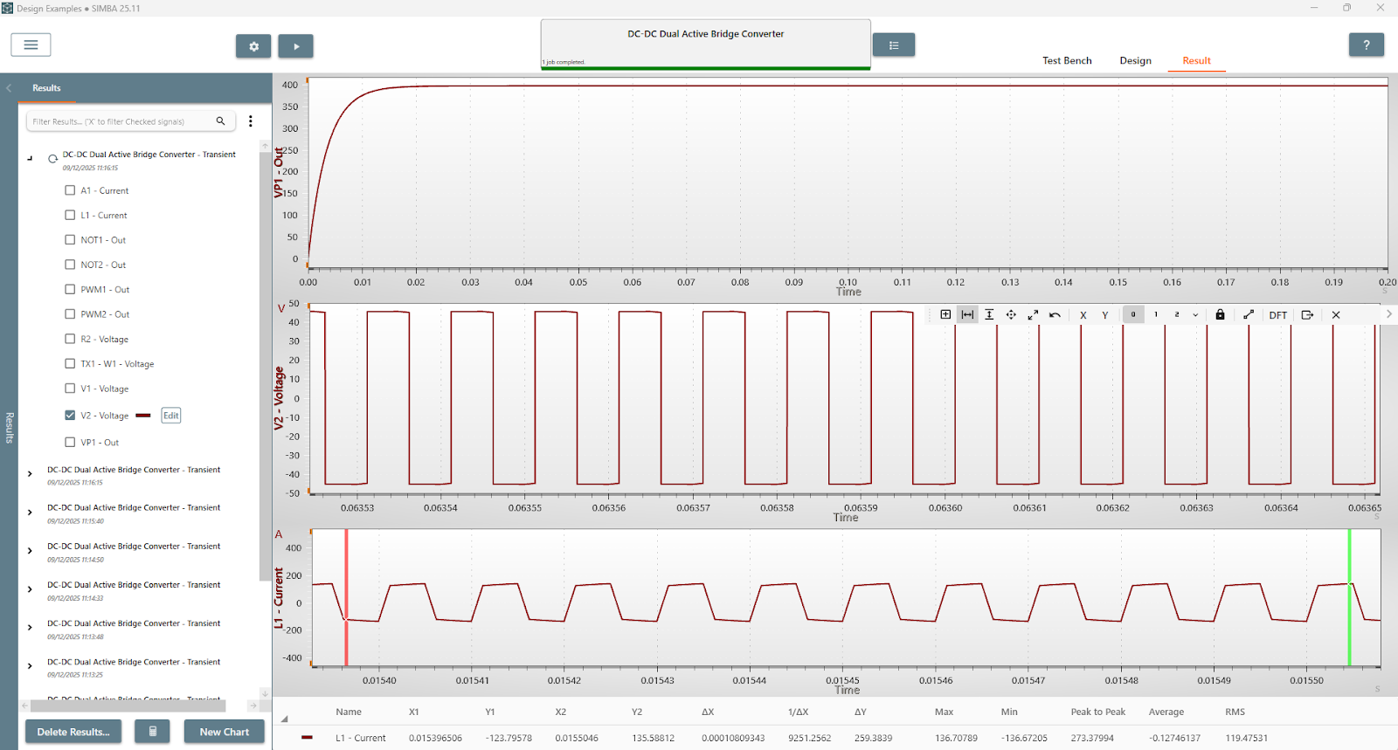

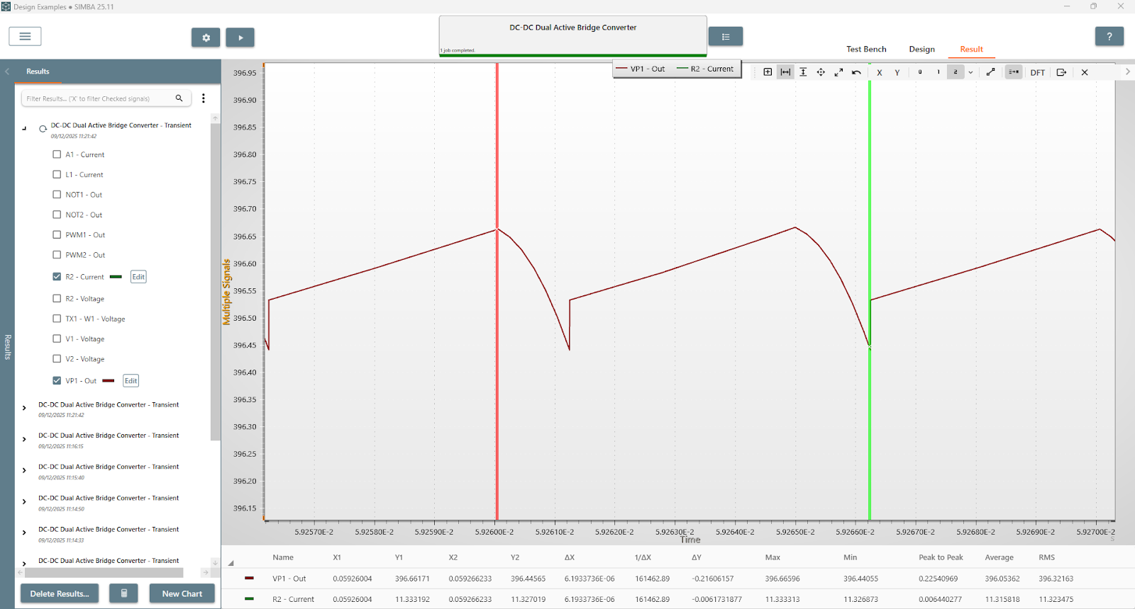

Validation:
396 V on 200 Ohm resistor -> P = V^2 / R = (396^2) / 35 = 4480.457 W

Note that 50 mOhm Rds_on MOSFETs resulted in a significant voltage drop. Changed to 5 mOhm and this is the result.

Voltage ripple ~ 0.2 V

Input into openmagnetics:
Core: https://uk.rs-online.com/web/p/transformer-cores/6479389
Coil former: https://uk.rs-online.com/web/p/transformer-accessories/1253682

Windings:https://www.rmcybernetics.com/shop/wire-cable/litz-wire
“40A” and “6A” variants for primary and secondary respectively. Should be possible to wind to get ~450 nH leakage

Costs:
- Core = £18.54
- Primary wire (1 m) = £18
- Secondary wire (10m) = £38
- Coil former = £10
- Total ~ £85

Ranges from 293 nH to 1300 nH depending on winding arrangement.

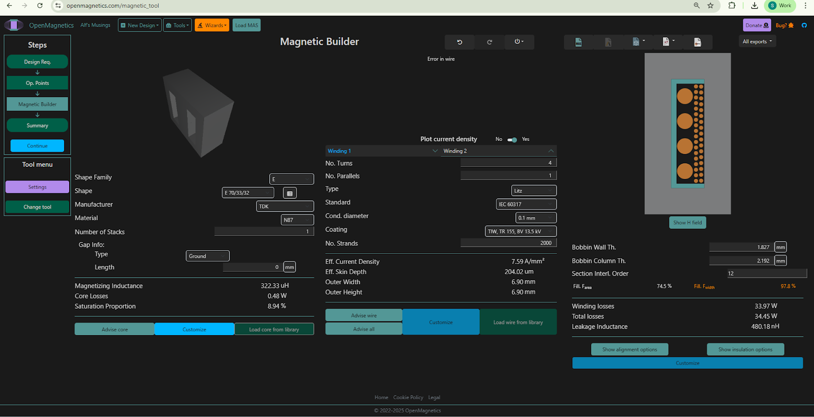

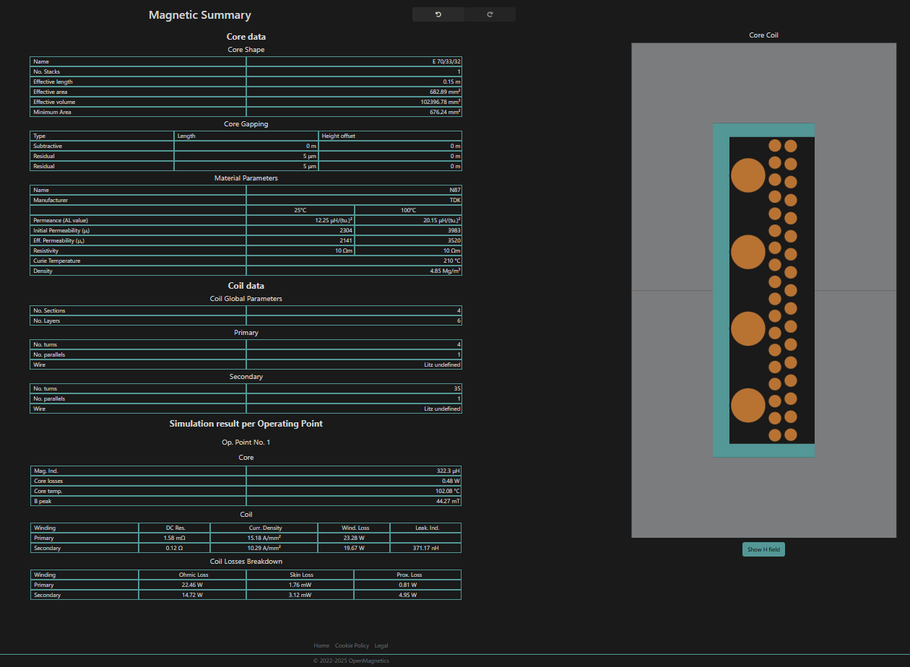

Approximately 44 W of losses to deal with on the E type design.

Magnetics iterations
Tried out both a Toroidal core and an ETD core.
The toroidal core option came in at low cost and low loss. 1.7 W core loss, 26 W of winding losses. BUT the winding and mounting arrangements required extra consideration. There was no off-the-shelf mount for the toroid and with Litz wire it wouldn’t be self-supporting.

So the ETD option comes in with ~22 W of total losses after adjusting the number of windings slightly and the size of the secondary Litz wire. It’s likely the losses of the other variants could have been reduced to these levels with some tweaking.

Litz vs non-Litz. At 100 kHz and these current levels, the difference between Litz and standard wires was significant! It made 10’s of Watts of loss difference for similar size wires. Likely to cause some serious overheating problems, as well as the efficiency hit!
The plus side of using the ETD core (ETD 59/31/22) is also that you can buy an off-the-shelf winder and yoke (to clip the core to the winder). This is useful because it gives a really nice mounting arrangement that lets you directly insert the transformer into a PCB or connect up with wires for testing.

